**OK3568-C Single Board Computer based on Rockchip RK3568**

Linux4.19 QT5.14 Cortex-A55 Quad-core RK3568 Single Board Computer multi-media AIOT Industrial.

Price **$190.00 - $250.00**

**Product Description:**

* OK3568-C single board computer(SBC) is populated with SoM FET3568-C on carrier board by four ultra-thin connectors. The carrier board ensures the SoM source fully available to achieve users' fast evaluation purpose.
* FET3568-C SoM is equipped with quad-core 64-bit Cortex-A55 processor with built in NPU based on advanced 22nm processing technology, running at up to 2.0GHz, and plenty of high-speed peripheral interfaces are available.

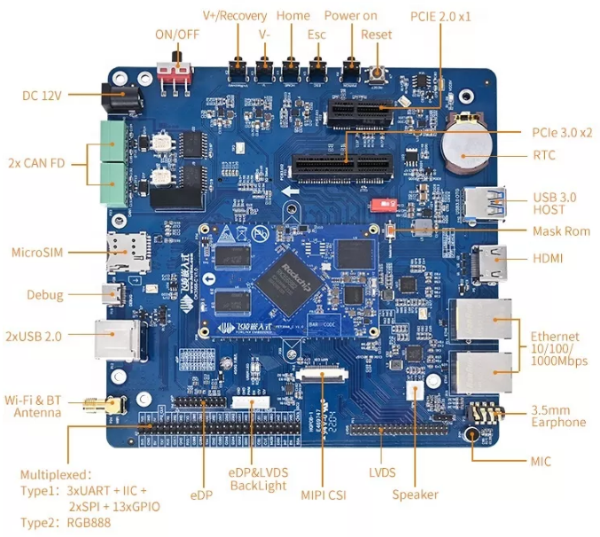

**OS Supporting**

FET3568-C SoM supports Linux 4.19 and Android 11 operating systems that deeply optimized, which ensures high-stability for long-last running.

**SoM FET3568-C Features**

|  |  |
| --- | --- |
| CPU | Rockchip RK3568 quad-core Cortex-A55@2.0GHz |
| GPU | • Mali-G52-2EE  • OpenGL ES 1.1, 2.0, 3.2, Vulkan 1.0,1.1, OpenCL 2.0 |
| NPU | 1TOPS, Support INT8/INT16/FP16/BFP16 mixed operation. |
| VPU | Decode:  • H.264, H.265, VP9: up to 4096x2304@60fps  • VP8: up to 1920x1088@60fps  • VC1, MPEG-4, MPEG-2, MPEG-1: up to 1920x1088@60fps  • H.263: up to 720x576@60fps  Encode:  H.264/AVC, H.265/HEVC: up to 1920x1080@60fps |
| RAM | 2GB |
| Flash | 16GB eMMC |
| Working Temp | 0℃ to +70℃ |
| Dimensions | 45x 70mm |
| Voltage Input | DC 5V |
| OS | Linux4.19+Qt5.12, Android11* |
| Display | 3  3 display controllers which can support simultaneous output of any 3 combinations in RGB, LVDS, MIPI DSI, HDMI and eDP  • RGB: RGB888, resolution up to 1280x800;  • LVDS: single-lane output, up to 1280x800, multiplexed with MIPI-DSI0;  • MIPI-DSI: single-lane output, up to 1920x1080@60Hz; dual-lane output up to 2560*1440@60Hz;  • HDMI: up to 1080p@120Hz or 4096x2304@60Hz;  • eDP: eDP 1.3, up to 2560x1600@60Hz; |
| Audio | 1X 8ch I2S/TDM, 2X2ch I2S, 1x8ch PDM. |

**OK3568-C Carrier Board Features**

|  |  |
| --- | --- |
| Display | HDMI2.0, up to 1080p@120Hz or 4096x2304@60Hz;eDP1.3, up to 2560x1600@60Hz; LVDS, single-lane output, up to 1280x800; RGB888 up to 1280x 800, multiplexed with SPI0, SPI2, UART3, UART4, UART5, and UART7, which are all configurable MIPI-DSI1, single-lane, up to 1920x 1080@ 60Hz |
| Camera | MIPI-CSI, recommended model OV13850 |
| Audio | 1x stereo earphone output, 1x 1.3W D-amplifier, 1x MIC input |
| TF card | for storage expanding and firmware installation |
| Ethernet | 2x 10/ 100/ 1000Mbps auto-negotiation, RJ45 connector |
| 4G/ 5G modem | M.2 Key-B slot, contains USB3.0/2.0, for 4G/ 5G modem expanding, recommended model: EM05*CE(4G, compatible with EC20), RM500U-CN(5G) |
| WiFi& BT | on-board AW-CM358SM, dual-band WiFi, BT5.0WiFi is based on one SDIO channel, and BT is based on one UART |
| USB2.0 | 2x USB2.0 Host, Type-A |
| USB3.0 | 1x USB3.0 Host, Type-A |
| USB2.0 OTG | USB2.0 in USB3.0 could be used as slave mode for OS installation and ADB debug |
| PCIe2.1 | standard PCIex1 slot, could be multiplexed and configured to SATA |
| PCIe3.0 | standard PCIe x4 slot, could be configured to 2x PCIe x1 |
| UART | 3x 3.3V TTL header with pitch of 2.54mm |
| CAN | 2x CAN-FD, up to 5Mbps, isolated and with ESD protection |
| SPI | 2x 3.3V TTL header with pitch of 2.54mm |
| IIC | 1x 3.3V TTL header with pitch of 2.54mm |
| 4G/ 5G | M.2 Key-B slot, contains USB3.0/2.0, for 4G/ 5G modem expanding, recommended model: EM05*CE(4G, compatible with EC20), RM500U-CN(5G) |
| RTC | recommended model CR2032 |
| Key | 8, including reset, power key, OTG, Maskrom, VOL+, VOL-, Home and ESC |
| QSPI | 32MB QSPI Nor Flash |
| Debug | expanded by USB, Type-C connector |
| Voltage input | DC12V |

**Other development boards of SoM FET3568-C:**

1. Rockchip RK3568 Based Linux Single Board Computer (OK3568-C )

**$190.00 - $250.00**

1. Rockchip RK3568 Development Board Kit (OK3568-C)

**$190.00 - $250.00**